

**NAME:**

**UQBA GULZAR**

**REG NO:**

**2023-BSE-067**

**SECTION:**

**BSE IIIB**

**COURSE TITLE:**

**OS Lab**

**LAB 02**

Verify that you are in your home directory. Make the directory *FIRST* using the following

command. List the files in the current directory to verify that the directory *FIRST* has been made correctly. Change directories to *LABS*. Create the file named *file1.* List the contents of the file *file1* to the screen. Make a copy of the file *file1* under the name *file2*. Verify that the files *file1* and *file2* both exist. List the contents of both *file1* and *file2* to the monitor screen. Then delete the file *file1*. Clear the window. Rename *file2* to *thefile*. Copy *thefile* to your home directory. Remove

*thefile* from the current directory. Copy *thefile* from your home directory to the current directory. Change directories to your home directory. Remove *thefile* from your home directory and from directory *LABS*. Verify *thefile* is removed from the directory *LABS.* Remove the directory *LABS* from your home directory with the following command. Verify that *thefile* and *LABS* are gone from your home directory.

**Output:**

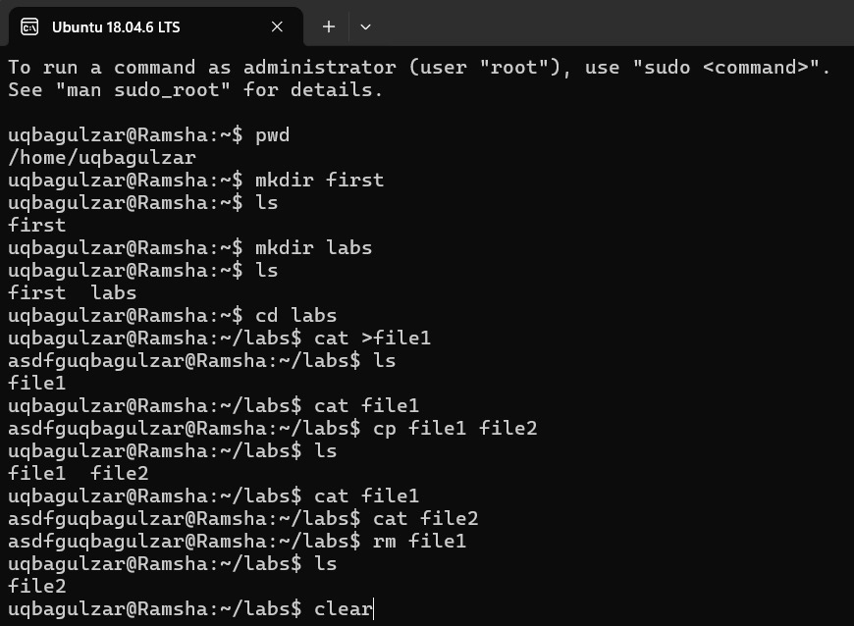

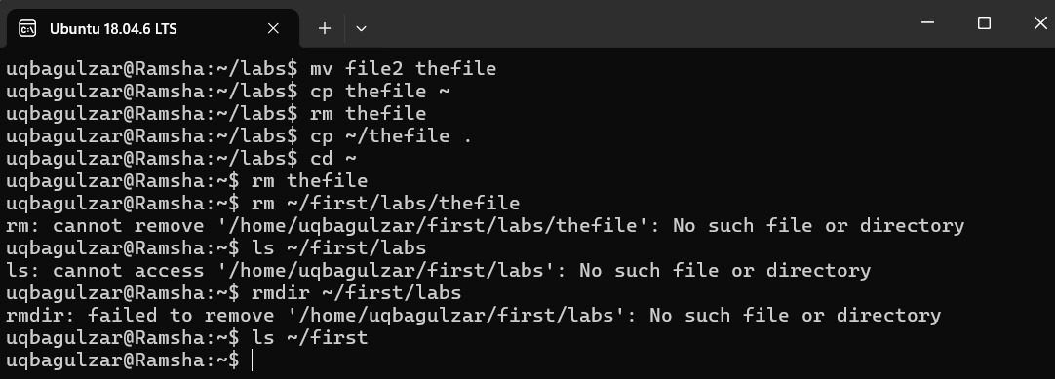

**Linux Top 50 Commands**

**Touch:**

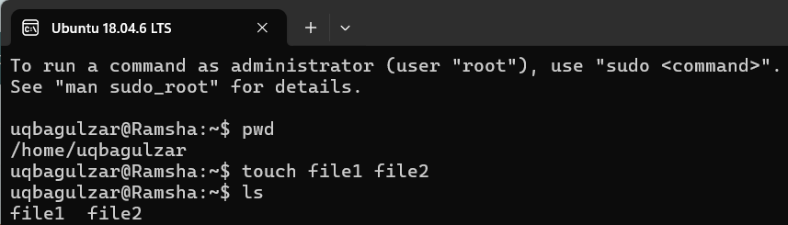

**Cat:**

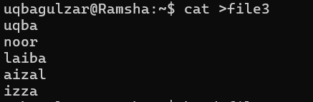

**Head:**

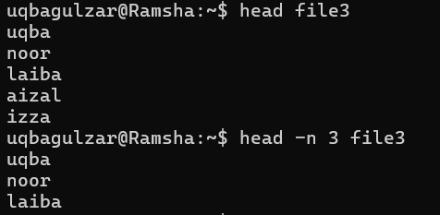

**Tail:**

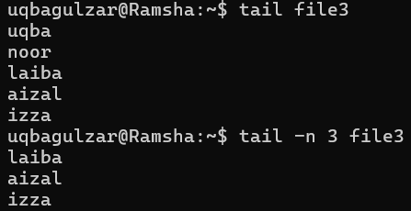

**Tac:**

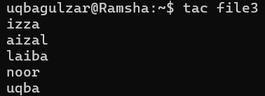

**More:**

**Less:**

**Id:**



**Useradd:**

**Passwd:**

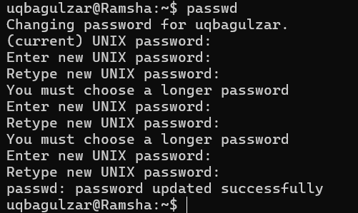

**Groupadd:**

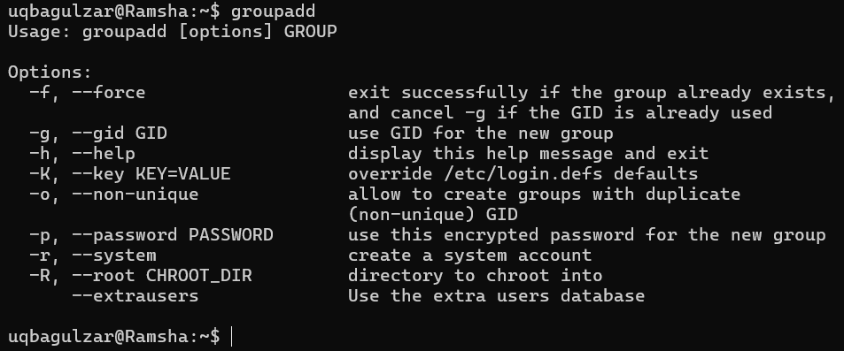

**Cut:**

**Grep:**

**Comm:**

**Sed:**

**Tee:**

**Tr:**

**Uniq:**

**Wc:**

**Od:**

**Sort:**

**Gzip:**

**Gunzip:**

**Find:**

**Locate:**

**Date:**

**Cal:**

**Sleep:**

**Time:**

**Zcat:**

**Df:**

**Mount:**

**Exit:**

**Ip:**

**Ssh:**

**Mail:**

**Ping:**

**Host:**